**Here is a photo of our work from class today: -**

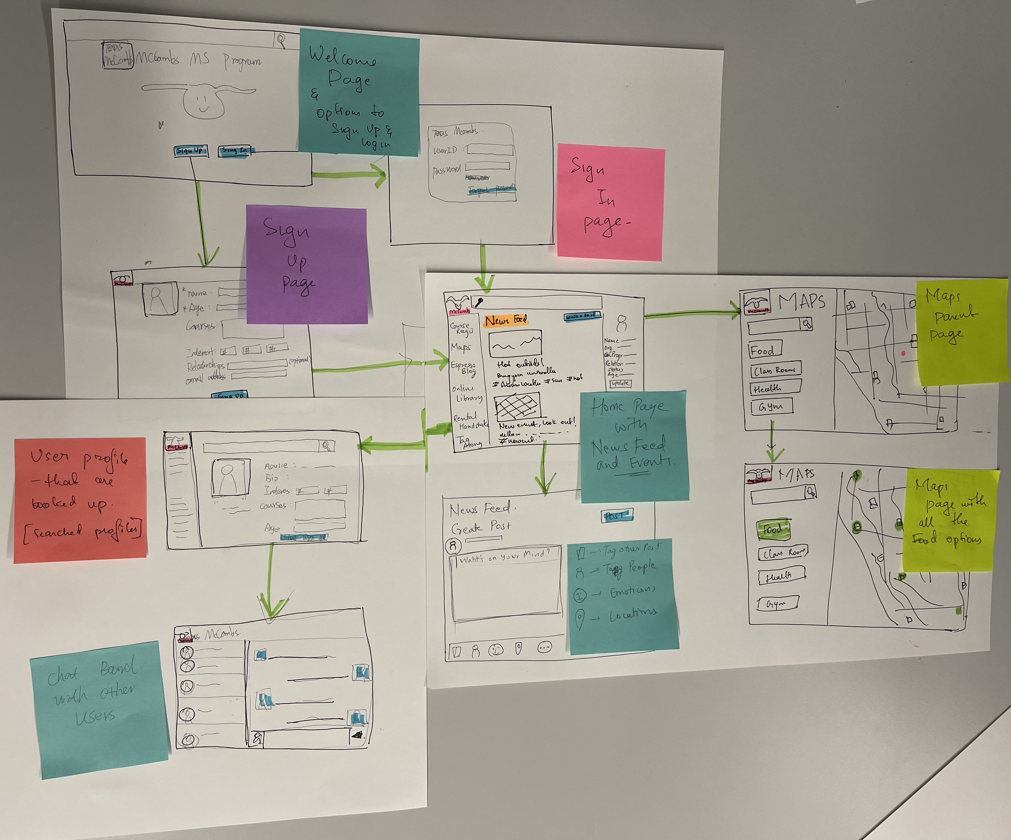

**Here is a picture of our user and organization goals: -**

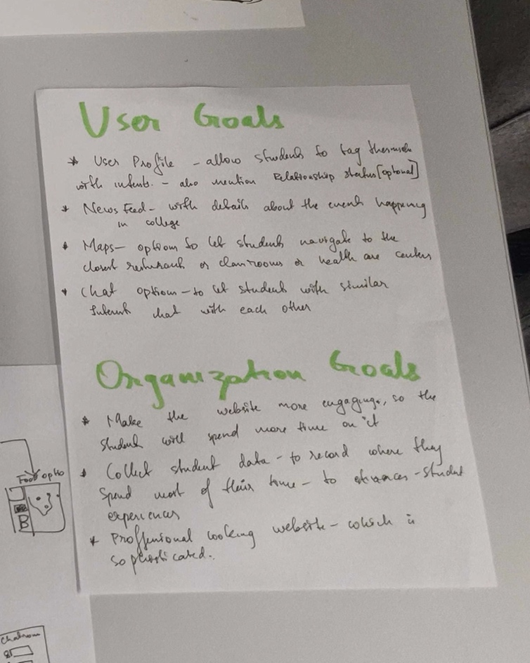

**User Goals: -**

1. A user profile option, where the students will be allowed to tag themselves with interest, this feature will provide a platform for the students to find others with similar interests. Relationship status can be one of the optional fields under the student profile. It could state whether the student is currently in a committed relationship or not.
2. News feed - This page would have details of all the upcoming events in and around the college. It would also have links to blog posts for studies or interview purposes. This page would allow students to post a new event too.
3. Maps - Navigating the school buildings to find your class can be exhaustive. With this new map feature, a student can locate his classroom and walk toward it. This map also provides options to look for the closest restaurants and such.
4. Chat room - A student can search for other students with similar interests and start a conversation with them.
5. Virtual library- where students can refer to online pdfs of books and other articles.

**Organization Goals: -**

1. The college would want the site to be more engaging, making their students spend quality time on it.
2. Collecting student data to record where they spend most of their time while visiting the site, use this information to enhance the website.
3. A website that looks professional and sophisticated.

**Here are some of the weaknesses of this Idea: -**

1. The students are allowed to post content on the news feed page. There is no way to monitor this just yet. So, we could make it advance by adding some AI feature to detect the words and type of images they are using to post so that we could look for potential triggers.
2. Privacy could be another weakness in this idea because all user profiles are currently public. We could add a feature to let them be private. This way, they wouldn't feel like the site is invading their privacy.
3. Copyright could be an issue with the books available in the virtual library.

**Here are some of the strengths of this Idea: -**

1. Students can find it hard to make connections and friends in a new program. This can be made easier by providing a platform for them to look for others with the same interests, hence increasing the chances of them finding someone who could become a potential buddy.
2. The map feature allows students to look for cafeteria and food stalls close by, making their lunch plans more straightforward and accessible.
3. Students will need not go to shady websites to download free versions of textbooks anymore. With the help of a virtual library on the site, one can type in the book's name and get the link to download it for free.

**Here is a mock-up/prototype of the “news feed” page: -**

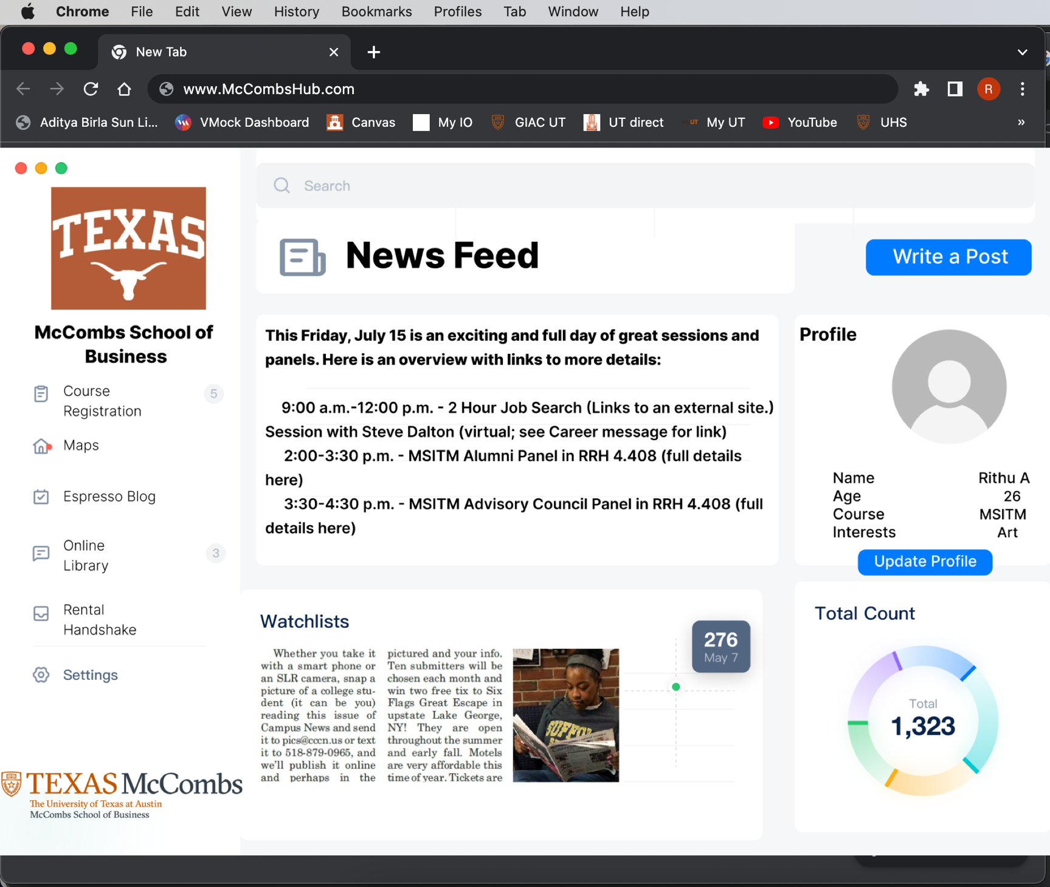

Created this with figma, online tool.